

ServiFinance: A Multi-Tenant SaaS Service Management System with Embedded Micro-Lending

In Partial fulfillment of the requirements
In IT13/L Professional Track for IT 4

Presented By:
Villacino, Christopher Llander L.

Presented To:

Lloyd Ryan Largo
IT13/L Adviser

May 2026
Business Case
Background
ServiFinance is a multi-tenant service management and finance platform. Its web side, called SMS, handles tenant service operations such as customer records, service requests, dispatch, technician work, status tracking, invoicing, and reports. Its desktop side, called MLS, handles finance workflows that should be separated from normal service operations, including invoice-to-loan conversion, standalone loan processing, amortization, payment posting, collections, ledger review, audit review, and financial reporting.

Purpose
The purpose of ServiFinance is to address the operational and financial challenges faced by Philippine MSMEs by integrating service management and micro-lending into a single secure system. Many businesses can deliver high-value services but struggle to provide structured and reliable credit options to customers. ServiFinance bridges this gap by enabling enterprises to manage services, customer accounts, and micro-loans within one platform, improving both operational efficiency and financial control.

Identified Problems and Proposed Solutions
Problem 1: Limited ability of MSMEs to offer structured credit
Many MSMEs lose potential sales because they cannot provide organized installment-based payment options for high-cost services. Access to financing remains a persistent constraint for small businesses, limiting growth opportunities and customer retention (IFC, 2017).
Solution:
ServiFinance provides an embedded micro-lending module that allows businesses to convert completed services into manageable credit transactions. This helps MSMEs offer flexible payment arrangements while maintaining proper monitoring of loans, due dates, and balances.

Problem 2: Manual financial recording leads to transaction errors
Businesses that rely on handwritten ledgers or spreadsheets for loan tracking are exposed to errors in interest computation, balance updates, and payment reconciliation. Spreadsheet-based processes are especially prone to hidden formula and encoding mistakes, which can undermine financial accuracy (Panko, 2016).
Solution:
The desktop terminal automates loan computation, amortization schedules, interest calculations, and payment posting. This reduces human error and ensures more accurate, consistent, and traceable financial records.

Problem 3: Disconnected records and weak security create data risks
When service records, customer information, and payment histories are stored separately, businesses face poor data visibility, delayed reconciliation, and reduced decision quality. At the same time, sensitive financial information requires controlled access and proper monitoring to reduce misuse and unauthorized handling (Caserio & Trucco, 2020; NIST, 2024).
Solution:
ServiFinance centralizes service, customer, and lending data in one secure environment with role-based access and audit logging. This improves data integrity, strengthens accountability, and supports safer management of sensitive financial transactions.

Objectives
- Provide a secure desktop entry point for tenant finance users.
- Convert finalized SMS invoices into micro-loan accounts.
- Support standalone loan creation when the loan does not originate from a service invoice.
- Calculate amortization schedules based on principal, interest rate, term, and start date.
- Post loan payments and update installment status, running balance, and ledger records.
- Provide customer financial records that combine loans and payment history.
- Provide collections, reports, ledger, audit, role, and platform-user administration views.
- Keep SMS service operations and MLS finance operations separated by surface and role scope.

Scope
The Desktop MLS scope includes:
- MLS desktop login
- MLS dashboard
- customer financial records
- invoice-to-loan conversion
- standalone loan processing
- loan accounts and payment posting
- collections queue
- reports
- ledger review
- audit review
- platform users
- roles and permissions

The current desktop MLS is focused on tenant finance operations. Superadmin desktop mode, multi-tenant employee switching, deeper export formats, and more advanced correction workflows can be treated as future enhancements unless required for final submission.

Stakeholders
Stakeholder | Interest In The System
Tenant Owner / Administrator | Controls tenant users, roles, reports, and finance oversight.
Finance Staff / Loan Officer | Converts invoices into loans, creates standalone loans, reviews accounts, and monitors balances.
Cashier | Posts payments and checks collections or ledger entries.
SMS Staff / Dispatcher / Technician | Produces the service and invoice records that may become finance-ready.
Customer | Receives service, invoice, and loan/account settlement visibility through customer-facing records.
Superadmin | Governs the platform, tenant subscriptions, modules, and root-level administration.

Business Benefits
- Reduces duplicate encoding between service operations and finance records.
- Improves traceability from service request to invoice to loan account.
- Helps finance staff compute installment schedules consistently.
- Provides a dedicated ledger trail for loan creation, payment posting, and reversals.
- Separates desktop finance functions from web-based service operations.
- Supports premium tenant value through desktop finance modules.
- Improves auditability for sensitive financial actions.

Risks And Controls
Risk | Control
Incorrect money computation | Use backend-controlled amortization, payment posting, and ledger update rules.
Unauthorized MLS access | Use desktop-only routing, authenticated sessions, role checks, and tenant scope validation.
Duplicate payment posting | Validate action state and record ledger transactions with references.
Weak traceability | Store finance actions in ledger transactions and audit events.
Tenant data leakage | Keep tenant-owned records linked by TenantId and protect APIs by tenant context.
Desktop/backend startup failure | Desktop host bootstraps and waits for the owned backend before using API-backed screens.

Importance
ServiFinance is important because it enables MSMEs to improve customer service, increase revenue opportunities, and maintain stronger control over financial operations. By combining service management and micro-lending in one desktop-based system, it supports more reliable decision-making, more secure data handling, and more sustainable business growth.

Conclusion
In conclusion, the desktop-side Micro-lending System addresses three major business problems encountered by MSMEs: the limited ability to offer structured credit, the high risk of transaction errors caused by manual recording, and the security and data risks created by disconnected records. To respond to these issues, the proposed system integrates micro-lending functions with service management, automates financial computations such as amortization and payment tracking, and centralizes sensitive records in a controlled desktop environment with improved access management and auditability. These recommendations strengthen operational efficiency, improve financial accuracy, reduce risk, and support better decision-making. Overall, the proposed solution contributes to business improvement by enabling MSMEs to serve customers more effectively while maintaining secure, reliable, and well-organized financial operations.

Methodology
This business case used a descriptive and problem-solution approach in analyzing the needs of MSMEs and in developing the proposed desktop-based Micro-lending System. The study began by identifying common operational and financial difficulties experienced by small businesses, particularly in handling installment payments, monitoring receivables, and maintaining accurate service and payment records. Relevant academic literature, institutional reports, and security guidance were reviewed to establish the practical and theoretical basis of the identified problems.
The analysis focused on how current manual or disconnected processes affect transaction accuracy, information quality, and data security. From these findings, corresponding system-based solutions were formulated using a business process improvement perspective. The proposed features of the desktop system, such as automated loan computation, centralized record management, and controlled user access, were then aligned with the objective of improving operational efficiency and financial reliability. This methodology ensured that the recommendations were not only technically appropriate but also responsive to the actual business challenges faced by MSMEs.

Tools
1. Microsoft Word - Used to write, organize, and format the business case, proposal content, and supporting documentation.
2. Visual Studio Code (VS Code) - Used for editing source code, reviewing project files, managing frontend and backend components, and maintaining documentation during development.
3. Visual Studio 2022/2026 - Used as the primary integrated development environment for building, debugging, and running the .NET-based components of the ServiFinance system, including the backend API and desktop application.
4. .NET and ASP.NET Core - Used to develop the core backend services of the system, including authentication, multi-tenant processing, API endpoints, business logic, and system integration.
5. .NET MAUI Hybrid - Used for the desktop-side implementation of the Micro-lending System, allowing the project to combine desktop application capabilities with a shared web-based user interface.
6. React and TypeScript - Used to build the user interface for the system’s web and desktop-facing screens, including dashboards, authentication views, and tenant-facing modules.
7. Vite - Used as the frontend build tool for compiling, bundling, and serving the React and TypeScript application efficiently during development.
8. SQL Server - Used as the primary relational database for storing tenants, users, customers, service requests, invoices, micro-loans, amortization schedules, and ledger transactions.
9. SQL Server Management Studio (SSMS) - Used to inspect, manage, and validate database structures, records, and queries during development and testing.
10. Entity Framework Core - Used for data access, database modeling, migrations, and interaction between the application and SQL Server database.
11. Git and GitHub - Used for version control, source code management, and tracking project changes during system development.
12. Online Research Sources and Academic References - Used to gather supporting literature, industry context, and credible citations related to MSME financing, transaction accuracy, ERP integration, and information security.

Gantt Chart
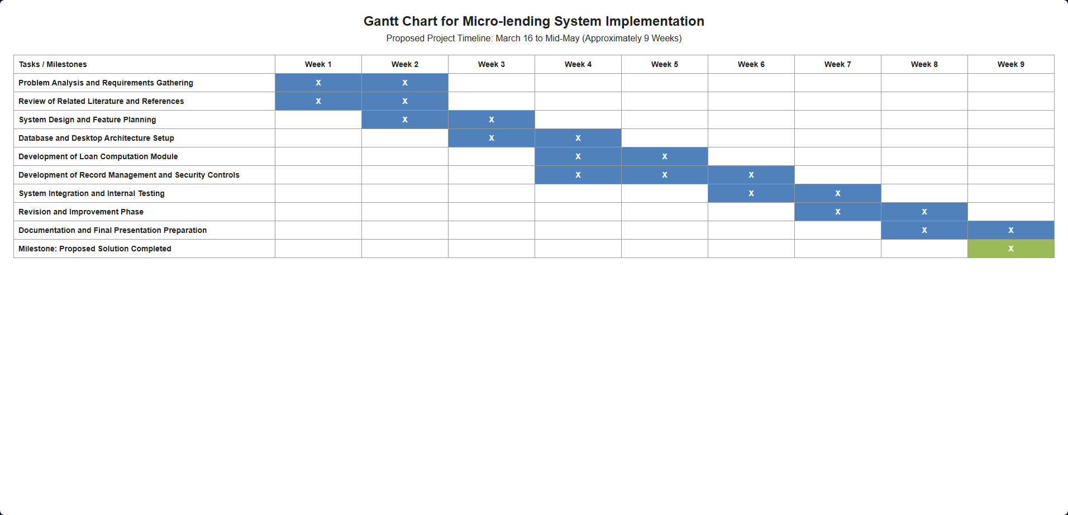

Use Case Diagram
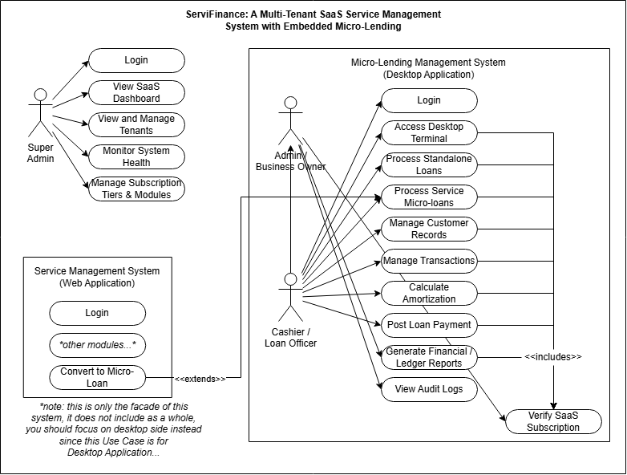

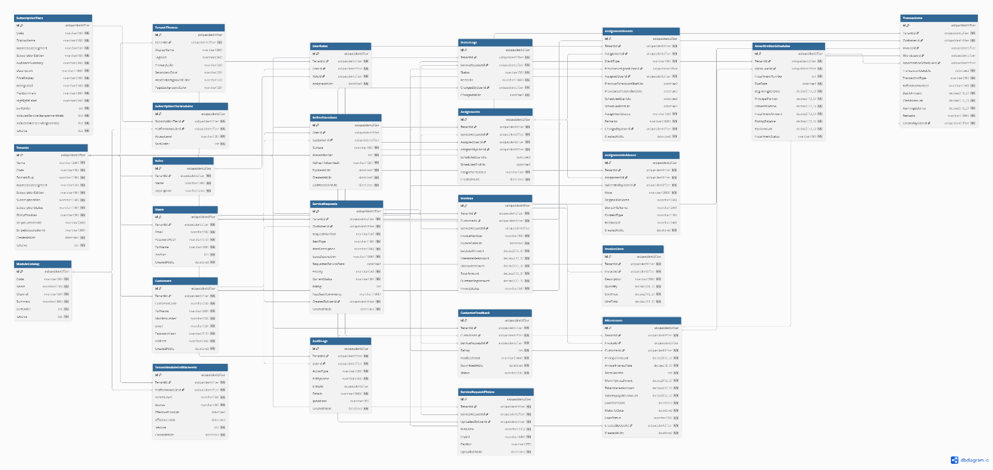
Entity Relationship Diagram

Data Dictionary
Tenants
Field | Data Type | Length / Precision | Description
Id | uniqueidentifier | 36 | Primary key of the tenant.
BusinessName | nvarchar | 200 | Tenant business name.
DomainSlug | nvarchar | 100 | Tenant route/domain identifier.
SubscriptionTierId | uniqueidentifier | 36 | Selected subscription tier.
IsActive | bit | 1 | Indicates whether the tenant is active.
CreatedAtUtc | datetime2 | - | Date and time when the tenant was created.

Users
Field | Data Type | Length / Precision | Description
Id | uniqueidentifier | 36 | Primary key of the user.
TenantId | uniqueidentifier | 36 | Tenant that owns the user, when tenant-scoped.
FullName | nvarchar | 200 | User full name.
Email | nvarchar | 50 | User email address used for login.
PasswordHash | nvarchar | 512 | Hashed password value.
IsActive | bit | 1 | Indicates whether the account can sign in.
CreatedAtUtc | datetime2 | - | Date and time when the user was created.

Roles
Field | Data Type | Length / Precision | Description
Id | uniqueidentifier | 36 | Primary key of the role.
TenantId | uniqueidentifier | 36 | Tenant that owns the role, when tenant-scoped.
Name | nvarchar | 100 | Role name such as Owner, Administrator, SMS Staff, MLS Staff, or MLS Cashier.
PlatformScope | nvarchar | 30 | Role scope such as Root, OwnerAdmin, SMS, or MLS.
Rank | int | 10 | Role rank used for ordering and governance.
IsSystemRole | bit | 1 | Indicates whether the role is system-defined.

UserRoles
Field | Data Type | Length / Precision | Description
UserId | uniqueidentifier | 36 | Foreign key to Users.Id.
RoleId | uniqueidentifier | 36 | Foreign key to Roles.Id.

Customers
Field | Data Type | Length / Precision | Description
Id | uniqueidentifier | 36 | Primary key of the customer.
TenantId | uniqueidentifier | 36 | Tenant that owns the customer.
CustomerCode | nvarchar | 50 | Unique customer code within the tenant.
FullName | nvarchar | 200 | Customer full name.
MobileNumber | nvarchar | 50 | Customer contact number.
Email | nvarchar | 50 | Customer email address.
Address | nvarchar | 500 | Customer address.
CreatedAtUtc | datetime2 | - | Date and time when the customer was created.

Invoices
Field | Data Type | Length / Precision | Description
Id | uniqueidentifier | 36 | Primary key of the invoice.
TenantId | uniqueidentifier | 36 | Tenant that owns the invoice.
CustomerId | uniqueidentifier | 36 | Linked customer.
ServiceRequestId | uniqueidentifier | 36 | Optional source service request.
InvoiceNumber | nvarchar | 50 | Unique invoice number within the tenant.
InvoiceDateUtc | datetime2 | - | Invoice issue date.
SubtotalAmount | decimal | 12,2 | Total before discounts.
InterestableAmount | decimal | 12,2 | Amount eligible for financing.
DiscountAmount | decimal | 12,2 | Discount applied to the invoice.
TotalAmount | decimal | 12,2 | Final invoice total.
OutstandingAmount | decimal | 12,2 | Remaining unpaid balance.
InvoiceStatus | nvarchar | 50 | Current invoice status.

InvoiceLines
Field | Data Type | Length / Precision | Description
Id | uniqueidentifier | 36 | Primary key of the invoice line.
TenantId | uniqueidentifier | 36 | Tenant that owns the invoice line.
InvoiceId | uniqueidentifier | 36 | Linked invoice.
Description | nvarchar | 500 | Billed item or service description.
Quantity | decimal | 10,2 | Quantity billed.
UnitPrice | decimal | 12,2 | Unit price.
LineTotal | decimal | 12,2 | Line total.

MicroLoans
Field | Data Type | Length / Precision | Description
Id | uniqueidentifier | 36 | Primary key of the micro-loan.
TenantId | uniqueidentifier | 36 | Tenant that owns the loan.
InvoiceId | uniqueidentifier | 36 | Optional source invoice.
CustomerId | uniqueidentifier | 36 | Linked customer.
PrincipalAmount | decimal | 12,2 | Principal loan amount.
AnnualInterestRate | decimal | 6,2 | Annual interest rate.
TermMonths | int | 10 | Repayment term in months.
MonthlyInstallment | decimal | 12,2 | Monthly installment amount.
TotalInterestAmount | decimal | 12,2 | Total interest for the loan.
TotalRepayableAmount | decimal | 12,2 | Principal plus total interest.
LoanStartDate | datetime2 | - | Loan start date.
MaturityDate | datetime2 | - | Final due date.
LoanStatus | nvarchar | 50 | Current loan status.
CreatedByUserId | uniqueidentifier | 36 | User who created the loan.
CreatedAtUtc | datetime2 | - | Date and time when the loan was created.

AmortizationSchedules
Field | Data Type | Length / Precision | Description
Id | uniqueidentifier | 36 | Primary key of the schedule row.
TenantId | uniqueidentifier | 36 | Tenant that owns the schedule row.
MicroLoanId | uniqueidentifier | 36 | Linked micro-loan.
InstallmentNumber | int | 10 | Sequence number of the installment.
DueDate | datetime2 | - | Installment due date.
BeginningBalance | decimal | 12,2 | Balance before the installment.
PrincipalPortion | decimal | 12,2 | Principal part of the installment.
InterestPortion | decimal | 12,2 | Interest part of the installment.
InstallmentAmount | decimal | 12,2 | Total installment amount.
EndingBalance | decimal | 12,2 | Balance after the installment.
PaidAmount | decimal | 12,2 | Amount already paid.
InstallmentStatus | nvarchar | 50 | Status such as Unpaid, Partial, or Paid.

Transactions
Field | Data Type | Length / Precision | Description
Id | uniqueidentifier | 36 | Primary key of the ledger transaction.
TenantId | uniqueidentifier | 36 | Tenant that owns the transaction.
CustomerId | uniqueidentifier | 36 | Linked customer.
InvoiceId | uniqueidentifier | 36 | Optional linked invoice.
MicroLoanId | uniqueidentifier | 36 | Optional linked micro-loan.
AmortizationScheduleId | uniqueidentifier | 36 | Optional linked amortization row.
ReversalOfTransactionId | uniqueidentifier | 36 | Optional original transaction when this row is a reversal.
TransactionDateUtc | datetime2 | - | Date and time of the transaction.
TransactionType | nvarchar | 50 | Type such as Loan, LoanPayment, or LoanPaymentReversal.
ReferenceNumber | nvarchar | 100 | Receipt or ledger reference number.
DebitAmount | decimal | 12,2 | Debit amount.
CreditAmount | decimal | 12,2 | Credit amount.
RunningBalance | decimal | 12,2 | Balance after posting.
Remarks | nvarchar | 1000 | Transaction notes.
CreatedByUserId | uniqueidentifier | 36 | User who posted the transaction.

AuditEvents
Field | Data Type | Length / Precision | Description
Id | uniqueidentifier | 36 | Primary key of the audit event.
TenantId | uniqueidentifier | 36 | Tenant that owns the audit event.
Scope | nvarchar | 50 | Workspace scope such as Platform, SMS, or MLS.
Category | nvarchar | 50 | Audit category such as System or Security.
ActionType | nvarchar | 100 | Action name being audited.
Outcome | nvarchar | 50 | Result of the action.
ActorUserId | uniqueidentifier | 36 | Optional user who performed the action.
ActorName | nvarchar | 200 | Actor display name.
ActorEmail | nvarchar | 50 | Actor email address.
SubjectType | nvarchar | 100 | Type of record affected.
SubjectId | uniqueidentifier | 36 | Optional affected record ID.
SubjectLabel | nvarchar | 300 | Human-readable affected record label.
Detail | nvarchar | 1000 | Audit event detail.
IpAddress | nvarchar | 80 | Source IP address when available.
UserAgent | nvarchar | 500 | Client user agent when available.
OccurredAtUtc | datetime2 | - | Date and time when the event occurred.

Module Diagram
Desktop MLS Module Diagram
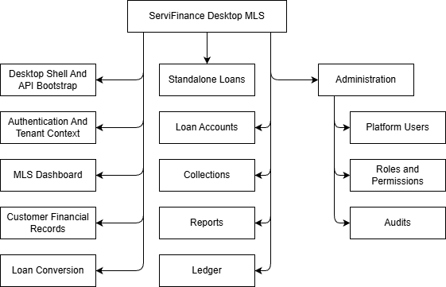

Module Responsibilities
Module | Main Responsibility
Desktop Shell And API Bootstrap | Starts the desktop experience and connects the MAUI host to the backend API.
Authentication And Tenant Context | Signs in tenant users and stores desktop session context.
MLS Dashboard | Shows finance overview, portfolio status, and important MLS metrics.
Customer Financial Records | Shows customer-level loans, balances, and ledger history.
Loan Conversion | Converts finance-ready service invoices into micro-loans.
Standalone Loans | Creates loans that do not originate from service invoices.
Loan Accounts | Reviews loan schedules, balances, payments, and reversible payment activity.
Collections | Shows due, overdue, and partially paid accounts for follow-up.
Reports | Shows finance and ledger reporting summaries.
Ledger | Shows transaction entries, balances, payment records, and finance trail.
Platform Users | Manages tenant users and assigns SMS/MLS platform roles.
Roles And Permissions | Manages available role behavior and permission matrix by platform scope.
Audits | Reviews MLS-related system and security events.

Process Flow Diagram
Desktop Access Flow
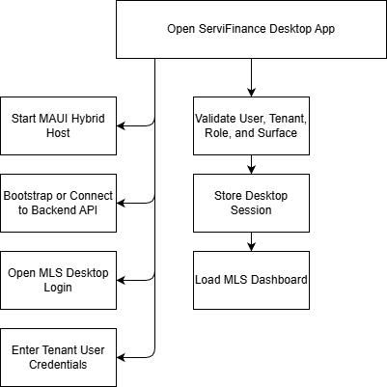

SMS Invoice to MLS Loan Flow
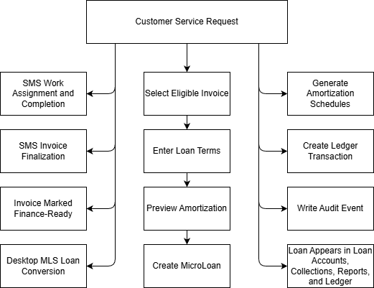

Standalone Loan Flow


Payment Posting Flow
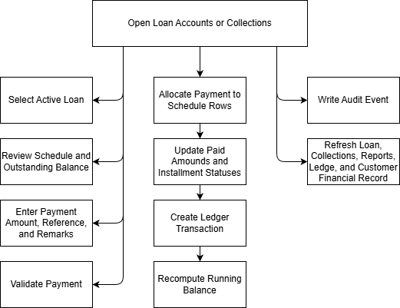

Payment Reversal Flow
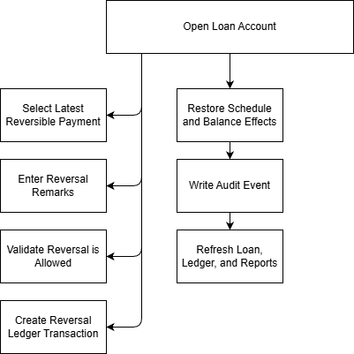

Reporting and Monitoring Flow
